**Cancer Care Ontario**

**Specialized Services Oversight (SSO)**

**Interventional Radiology Appendices**

***(Program previously designated as Focal Tumour Ablation)***

**Version 1.0 R7**

**26-Sept-2016**

# 

# Appendix-1: Facility Numbers[1]

|  |  |  |  |
| --- | --- | --- | --- |
| **#** | **Program Title** | **Submitting Hospital** | **Facility Number** |
| 27 | Interventional Radiology | Halton Healthcare Services | 950 |
| Hamilton Health Sciences Centre - JCC | 942 |
| Kingston Health Sciences Centre (KHSC) | 978 |
| Lakeridge Health | 952 |
| London Health Sciences Centre - University Hospital | 899 |
| London Health Sciences Centre - Victoria Hospital | 717 |
| London Health Sciences Centre | 936 |
| North York General Hospital | 632 |
| Royal Victoria Regional Health Center | 606 |
| Sinai Health System | 976 |
| St. Joseph’s Healthcare, Hamilton | 674 |
| St. Joseph’s Health Centre, Toronto | 898 |
| Grand River Hospital | 930 |
| Sunnybrook Health Sciences Centre | 953 |
| The Ottawa Hospital | 958 |
| Trillium Health Partners | 975 |
| University Health Network | 947 |
| Windsor Regional Hospital | 933 |
| Health Sciences North | 959 |
|  |  | St. Michael’s Hospital | 852 |

# Appendix-2: MOHLTC Master Numbering System[2]

The Master Numbering System has been developed for the purpose of bringing together all Health Facilities and Programs under one system of identification. The list is a composite of health and health related units, facilities, clinics, programs and services. Each such organization has been assigned a unique four digit identifying code.

(For details, please refer Cancer Care Ontario's Data Book - 2012-2013, Appendix A: MOHLTC Master Numbering System, at link <https://www.cancercare.on.ca/ext/databook/db1213/documents/Appendix/CCO_Appendix_A_APR_12.pdf>).

# Appendix-3: Valid 2-digit Postal Codes[3]

(Source: Cancer Care Ontario's Data Book - 2012-2013, Appendix B - Province and State codes, at link https://www.cancercare.on.ca/ext/databook/db1213/databook.htm).

The table below provides list of valid 2 digit postal codes for province and State codes.

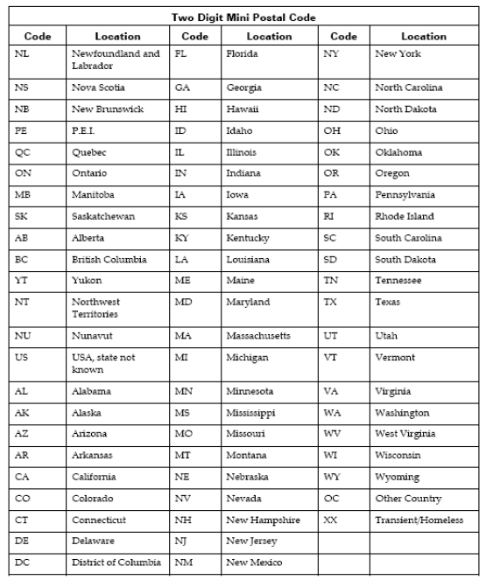

1. This corresponds to appendix 3 on ALR
2. This corresponds to appendix 13 on ALR
3. This corresponds to appendix 11 on ALR